**Notes**

**WAVE Web Accessibility Evaluation Tool**

<https://wave.webaim.org/>

WAVE is a collection of tools that web developers use to improve website accessibility for individuals with disabilities. This tool helps detect “accessibility and Web Content Accessibility Guideline (WCAG) errors.” In addition, WAVE helps web developers learn more about web accessibility and improve at designing accessible websites.

**AccessiBe website-Tool for checking accessibility**

<https://accessibe.com/ace>

A Department of Justice letter from September 2018 stated that “All business-related websites are considered places of public accommodations and must be accessible for people with disabilities.”

Web accessibility lawsuits have increased considerably from 2018, with there being around 120,000 lawsuits or a 300% increase in 2019.

AccessiBe checks your web domain and sends a report outlining how accessible your website is depending on the result of several tests. You can review the report once it is done. This service is free and primarily focused on WCAG 2.1 Level AA compliance, which is the main form for legal compliance.

Website App Public Accomodation ADA

<https://www.concordlawschool.edu/blog/news/website-app-public-accommodation-ada/>

Assistant Attorney General Stephen E. Boyd wrote that “a company’s website is subject to Title III if the company otherwise qualifies as a public accommodation.”

**Web Accessibility by Level Access**

<https://www.webaccessibility.com/>

Web Accessibility by Level Access allows you to enter a webpage url into a form and then checks how accessible that webpage is. This website is free to use, which makes it useful for organizations that want to avoid wasting money and for students who do not desire to spend money.

Level Access’ Elevin Community Edition displays information about how accessible a website is that is updated for free over time. Analysis can be conducted at any time as well, with the system automatically prioritizing the most important pages or components. This tool also alerts web developers to issues and where those issues are located. Elvin Community Edition also guidance and learning resources.

**W3 Accessibility Intro**

<https://www.w3.org/WAI/fundamentals/accessibility-intro/>

Communicating on the web is easier than communicating in the physical world since there are fewer communication and interaction barriers. Websites need to be well designed so that everyone can use the Web without being stopped by barriers that exclude them. Because of this, accessibility is important for making high quality websites that everyone can use.

Accessibility is where websites are “designed and developed so that people with disabilities can use them.”

Web accessibility pays attention to making sure people with disabilities can access the web. Some of disabilities that web accessibility focuses on include

* auditory
* cognitive
* neurological
* physical
* speech
* visual

Interestingly, web accessibility also helps people without disabilities access the web in different situations, such as when people temporarily cannot use their senses fully due to injuries or missing glasses. Making accessible websites also helps people who are using different devices that have small screens or have slow internet.

**Introduction to Understanding WCAG 2.0**

<https://www.w3.org/TR/UNDERSTANDING-WCAG20/intro.html>

Four principles guide the WCAG’s success criteria; websites need to be perceivable, operable, understandable and robust. Users need to be able to perceive information, meaning that cannot be invisible to all the user’s senses. Users need to be able to operate the interface, meaning that the interface cannot have operations a user cannot perform. Users need to be able to understand the information and operations. The content needs to be robust so that various user agents and technologies can interpret the website’s content. All of these principles need to be fulfilled or else users with disabilities will not be able to use the web.

Each guideline features several success criteria that need to be met so that the guideline is met. Success criteria are either passed or failed, with no in between. Fulfilling success criteria does not necessarily mean that a website is accessible; professionals should review the website and developers should conduct usability tests. Users with disabilities should be part of test groups to determine if the website is actually accessible.

**Lesson 20**

https://www.codecademy.com/learn/learn-intermediate-css

* Web accessibility is about providing a good user experience for everyone by making a website accessible. Not only do you want to make your website usable for everyone, but oftentimes there are legal requirements.
* The Web Content Accessibility Guidelines (WCAG) has three levels. Level A is the minimum level. If you do not meet this, then your website has serious issues. Level AA is an accessible level that most companies want to reach. Level AAA is a very accessible level.

**Visual Readability: Scale**

* You typically want the font-size to be around 18 to 20 px for smaller screens.
* Line-height is by default 1.2. Web Content Accessibility Standards recommend a line height of at least 1.5.
* Letter-spacing is another property that expands the space between letters.
* Typical spacing would be about 0.05em.

**Visual Readability: Color**

Make sure that colors contrast with each other so that way the text stands out from the background. This is especially important for people with vision impairments. Colors contrast from each other on the color wheel. They need to contrast by the correct amount.

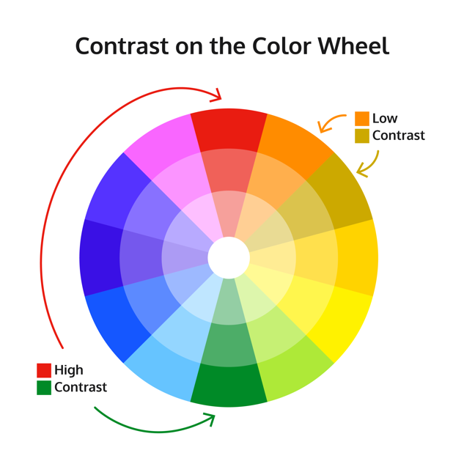

<https://static-assets.codecademy.com/Courses/Learn-CSS/Accessibility/color-wheel.png>

The WCAG ratios for AA are as follows.

* Font less than 24 px and not bold- 4.5:1
* Font less than 19 px and bold- 4.5:1
* Font larger than 24 px and not bold- 3:1
* Font larger than 19 px and bold- 3:1

WebAIM is a resource for determining color contrast.

<https://webaim.org/resources/contrastchecker/>

**Visual Readability: Structure**

* Text-align should be left, right or center.
* Rather than setting width to be px, you should set it to be ch. The total number of ch should be between 45 to 85, with 65 as the ideal.

**Contextual Readability: Interactivity**

Abbreviations can also have a title attribute.

<abbr title=’Cascading Style Sheets’>CSS</abbr>

In order to show people that elements can be clicked on, you should use the cursor property to display an element can be clicked on.

.button{

cursor: pointer;

}

Img elements have an alt attribute that is used when an image cannot be displayed.

**Contextual Readability: Color**

input:focus can be used to show users what element they are focused on. CSS colors can also be used to display the status of elements, such as by using border-color.

**Design Reflecting Structure**

Make sure that elements are properly structured. Elements should go in a logical order in an HTML document and elements when displayed by CSS should match the HTML. This will help people using screen readers.

**Accessibility Across Mediums**

Accessibility across mediums, such as smaller screens and printed materials, is important. Make sure to use @media print and @media only screen and {min-width:800px} for this.

**Labels**

Labels are used to connect text to inputs. Screen readers read a label out loud when a user is focused on an element. Users can also click on the text in a label element in order to toggle inputs such as radio buttons and checkboxes that may be hard to click.

<label for=”username”>Username:</label>

<input name=”username”>

<label for=”password”>Password:</label>

<input name=”password”>

**Web Content Accessibility Guidelines (WCAG)**

The web content accessibility guidelines outline goals for websites. It can be found here: <https://www.w3.org/TR/WCAG21/>. While this set of requirements is long, it is useful for making inclusive websites that everyone can enjoy using.

**Brainstorming**

1. What is accessibility in web design?
   1. Accessibility is making sure everyone can use your website.
2. Why is it important?
   1. Helps people with disabilities
   2. Helps make better websites
3. How is it measured?
   1. Boards/Standards that measure web design accessibility
      1. WCAG 2.0
   2. Tools that measure web design accessibility.
      1. WAVE
      2. AccessiBe
4. What are some easy ways I can apply it to my websites?
   1. (Lesson 20 Tips)